Use this reference edit or update an athletic team in Workday Student

INSTRUCTIONS

- In the search bar, type “View Athletic Team” and select the View Athletic Team report once it auto-populates.

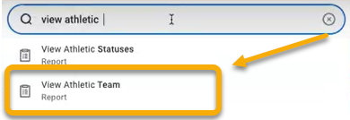

- In the View Athletic Team window, click the “Athletic Team” field and select the desired team. Click “OK”.

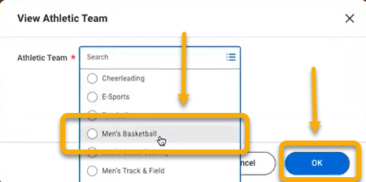

- The team’s page will appear with the option to update, remove, or add student athletes currently active on the team. See below for instructions on each option.

Task | Definition
Update | Every student that is an active member on the team must be updated each academic period. This is requested even if the student is studying abroad or otherwise not playing on the team, but still considered a team member and expected to participate in the future.  This update permits the opportunity to report on student athletes during specific academic periods.
Instructions:

- Click “Update” in the Actions column alongside the athlete’s name.
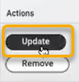

- In the Update Student on Athletic Team window, complete the fields as follows:

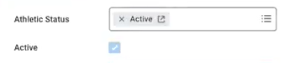
- In the Athletic Status field, select “Active”. This signifies the student is active on the team. Be sure the Active box is checked.

- The Athletic Role field is optional. If available, select most appropriate option.

- The Primary Athletic Team field only applies to athletes participating on more than one team. If this applies, make a selection.

- In the Academic Period field, enter the academic period corresponding to the student’s current active team status. Type the period and the field will auto-populate.


- Click “Submit”.

Task | Definition
Remove | This removes the student permanently from the team. This is required if the student graduates, for example.
Instructions:

- Click “Remove” alongside the athlete’s name.
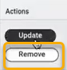

- In the Academic Period field, enter the period the student is no longer active on the team. Type the period and the field will auto-populate.

- In the Effective Date field, set to the actual date the student left or leave it as is. This date will default to the standard start date of the selected academic period.

For example, if the student graduates at the end of the fall 2024 academic period, then the student’s removal should be effective in the spring 2025 academic period. When spring 2025 is selected, the effective date will default to the standard start date of spring 2025.

The student will remain on the athletic team in Workday until the effective date of the removal occurs.


- Click “Submit”

Task | Definition
Add | A student who is not on the list, but is joining the team, must be added. To add, follow these instructions:
Instructions:

- Scroll to the bottom of the page and click “Add Athletic Team Member”.
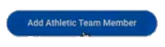

- In the Student field, enter the student name or ID. Select the student and click “OK”.

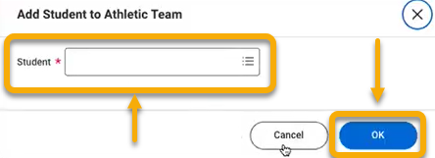


- In the Athletic Status field, select “Active”. Be sure the Active box is checked.

- The Athletic Role field is optional. If available, select most appropriate option.

- The Primary Athletic Team field only applies to athletes participating on more than one team. If this applies, make a selection.

- In the Academic Period field, enter the academic period corresponding to the student’s current active status on the team. Type the period and the field will auto-populate.
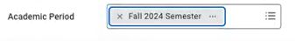
- Click “Submit”.


